# Structured Query Language (SQL)

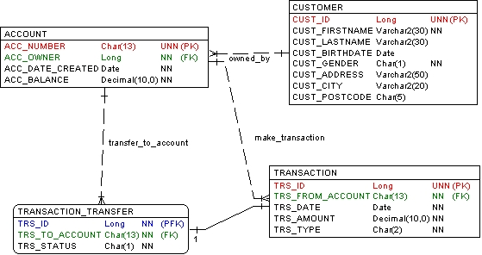

Note:

UNN : Unique, Not Null PK : Primary Key

FK : Foreign Key NN : Not Null

Table description:

1. CUSTOMER: contains all bank customer data

The column CUST_GENDER is set to 1 for male and 2 for female.

1. ACCOUNT: contains all customer accounts

The column ACC_OWNER is the Foreign Key which refers to the column CUST_ID of the table CUSTOMER.

1. TRANSACTION: records all transactions.

The column TRS_TYPE contains the transaction type with possible values:

* 1. DB: for debit transaction.
  2. CR: for credit transaction.
  3. TF: for money transfer. The column TRS_FROM_ACCOUNT contains the source account.

1. TRANSACTION_TRANSFER: contains additional information if the transaction is money transfer.

The column TRS_STATUS contains one of the following values:

* 1. 0: if transaction is not executed yet
  2. 1: if transaction is executed successfully
  3. -1: if transaction is failed (e.g. the balance of source account (TRS_FROM_ACCOUNT) is not available)

# Questions

Create SQL queries for the following requirements:

1. Recapitulation of number of accounts owned by every customer.

Answer:

SELECT customer.cust_firstname, COUNT(account.acc_number)

FROM ACCOUNT

INNER JOIN customer ON account.acc_owner = customer.cust_id

GROUP BY customer. firstname

1. All transactions created by John Michael sorted by account number and transaction date

Answer:

SELECT transaction.trs_amount,transaction.trs_from_account,transaction.trs_date,transaction.trs_type

FROM TRANSACTION

JOIN ACCOUNT

ON transaction.trs_from_account= account.acc_number

JOIN customer

ON account.acc_owner = customer.cust_id

WHERE customer.cust_firstname = 'John Michael'

ORDER BY transaction.trs_date ASC , transaction.trs_from_account ASC